# HOME PAGE.



1This gets hidden when we scroll down. It should show all the time, in all the pages.



2.This should be clickable link and different section. (look should be same as the above image.

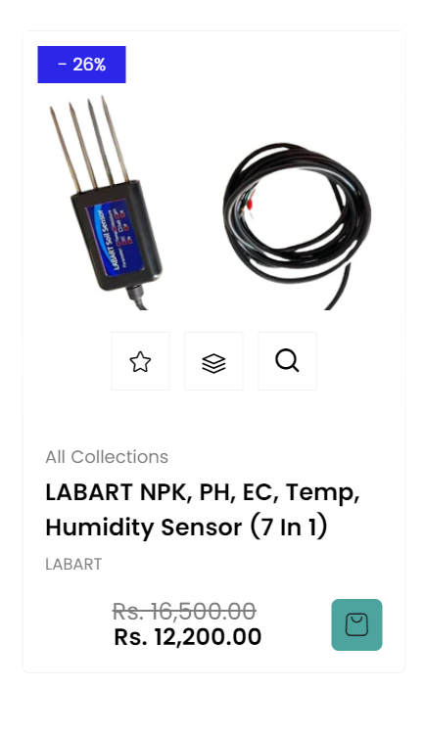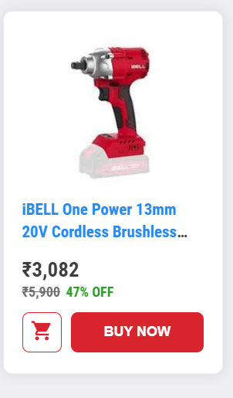

3. Add to cart icon button should be white with green background, also add buy now button beside this. For reference check the other image.

4.



offer price should be above . mrp will be below (show % OFF Also)

PRODUCT PAGE

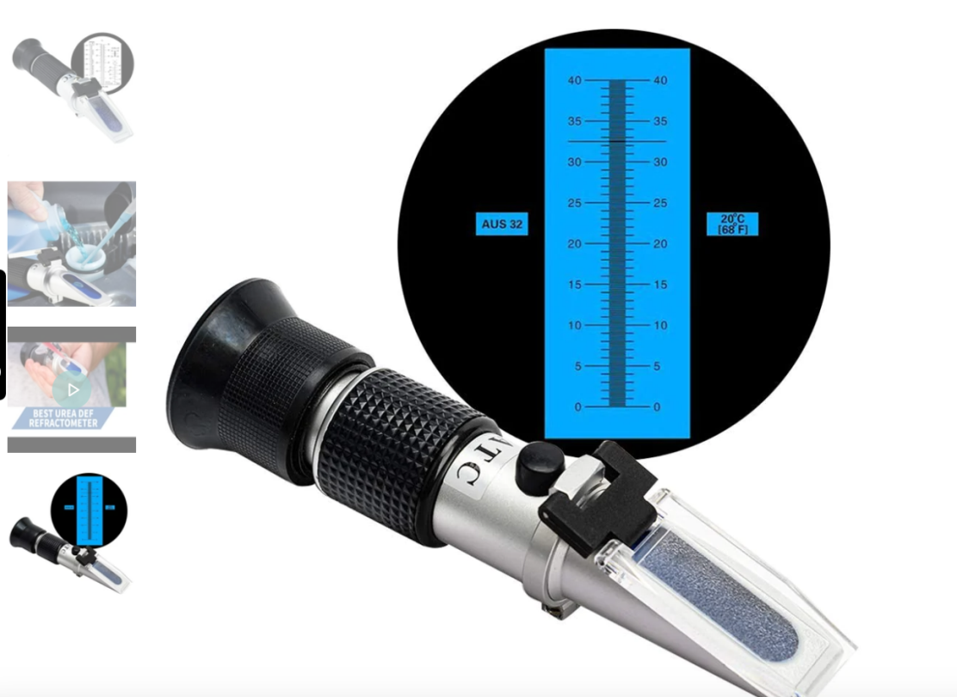

1. Product size is big.
2. MRP not showing in product page.
3. Offer Price bracket should be written (Incl. of all taxes)
4. ADD the below line (Under Offers & Coupans)

Check the link

<https://www.moglix.com/sameer-i-flo-15hp-monoblock-force-water-pump-with-1-year-warranty/mp/msn2r93i3cbi03>

add the below line 

1. Make this for discount offers:
2. 
3. 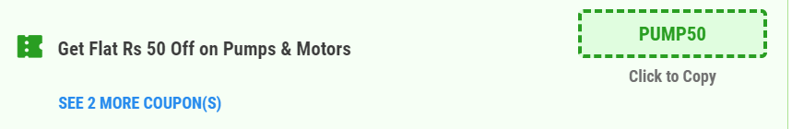
4. remove get a quote from below and make a separate this, redirect to contact us page meanwhile.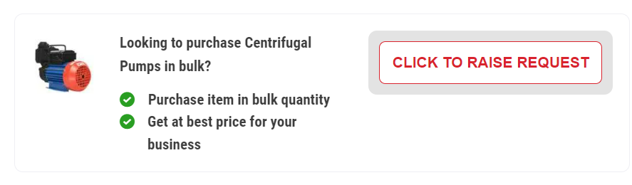
5. 

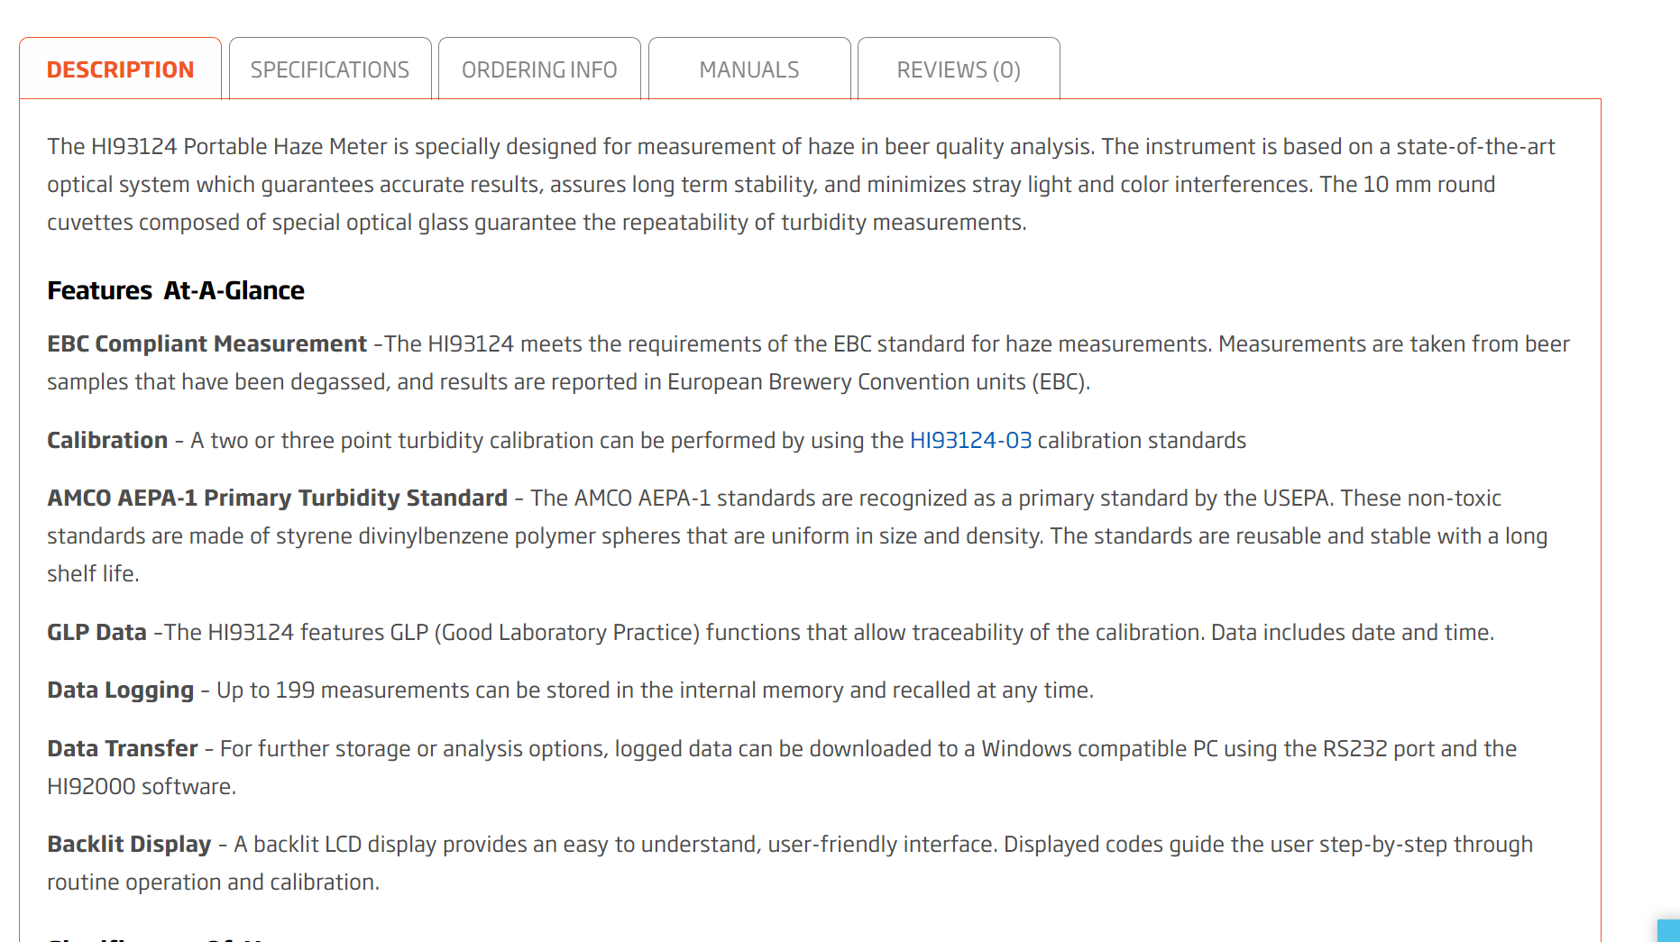

1. The look should be like this. (put under some background color the tabs
2. Resources : add one dummy pdf, & a video
3. Table will come under technical specification
4. Under specification : content will be text and some banner template images.

For banner template we need metablock content (call me for this if you don’t undertsnad)

1. 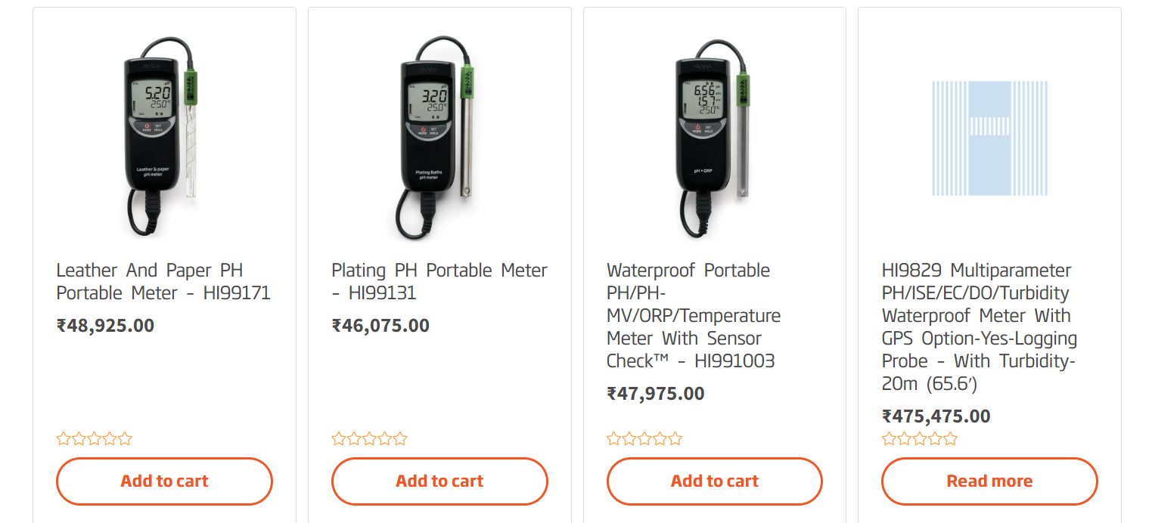

We wanted product title like this. So that alignment will be there

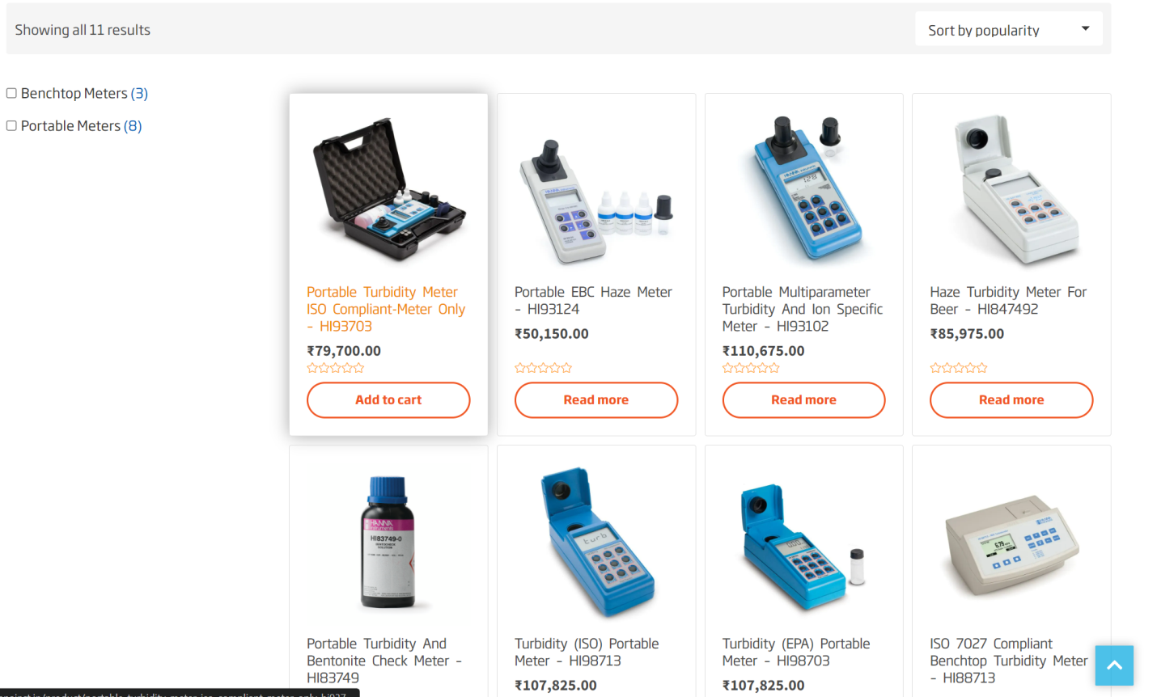

Please make boundary on products layout.